UNIVERSITY OF SCIENCE AND TECHNOLOGY OF HANOI
DEPARTMENT OF INFORMATION AND COMMUNICATION TECHNOLOGY



BACHELOR THESIS

By
Trương Đại An – 22BI13008

WPF Image Processing Application

Supervisor: Mr. Kiều Quốc Việt

Hanoi, July 2026

Hanoi, <Month – yyyy>

Hanoi, September 2013

HàNội, Sept. 2012
Declaration

I, Truong Dai An, of the Information and Communication Technology Department,
University of Science and Technology of Hanoi, confirm that this is my own work, and that all figures, tables, equations, code snippets, artworks, and illustrations in this report are original and have not been taken from any other person’s work, except where the works of others have been explicitly acknowledged, quoted, and referenced.
I understand that failing to do so will be considered an act of plagiarism. Plagiarism is a form of academic misconduct and will be penalized accordingly.
I give my consent to having a copy of my report shared with future students as an example.
I give my consent for my work to be made available more widely to USTH members and the public with interest in teaching, learning, and research.

Truong Dai An
June 28, 2026

To whom it may concern,
I, Kiều Quốc Việt, certify that the thesis / internship report of Mr Trương Đại An is qualified to be presented in the Internship Jury 2025 – 2026.

Hanoi, / /2026
Supervisor’s signature
Table of Contents
ACKNOWLEDGEMENTS 6
LIST OF ABBREVIATIONS 7
LIST OF TABLES 8
LIST OF FIGURES 9
ABSTRACT 10
I/ INTRODUCTION 11
1. Context and Motivation 11
II/ OBJECTIVES 12
1. Desired Features 12
2. Expected Outcome 12
3. Thesis structure 13
III/ REQUIREMENTS ANALYSIS 14
1. Overall System Requirements: 14
2. User & Non-functional Requirements: 15
2.1. User Requirement: 15
2.2. Availability 16
2.3. Re-usability 16
2.4. Reliability 16
3. Use Cases: 17
4. Use Case and Scenario Description: 17
4.1. Use Case 1: Image Queue Management 17
4.2. Use Case 2: Real-Time Basic Image Editing 20
4.3. Use Case 3: Precision Selection and Background Segmentation 21
4.4. Use Case 4: Look-Up Table Color Curves 23
4.5. Use Case 5: Batch Dataset Augmentation 24
4.6. Use Case 6: Application Optimization & Performance 26
IV/ METHODOLOGY 28
1. Overall System Architecture: 28
1.1. Development Tools 28
1.2. Optimization Techniques 28
2. System Architecture: 29
3. Use Case Implementation (Sequence Diagram) 31
3.1. Manage Image Queue 31
3.2. Adjust Image Parameters 33
3.3. Apply Image Filters 35
3.4. Fine-tune Color Curves 37
3.5. Interactive Object Segmentation 39
3.6. Configure & Run Data Augmentation 41
3.7. Batch Export Queue 43
V/ RESULTS 46
1. Accuracy and Processing Speed 46
1.1. Accuracy 46
1.2. Processing Speeds (Average Latency) 46
2. Discussion 47
VI/ CONCLUSION AND FUTURE WORKS 48
1. Conclusion 48
2. Future works: 48
REFERENCES 50

ACKNOWLEDGEMENTS
I would like to give my gratitude to Mr. Kieu Quoc Viet for their supporting and their best guidance throughout this project to me.
I'd also like to thank the teachers at the Information and Communication Technology Department - University of Science and Technology of Hanoi (USTH) for facilitating my studies and research.
There will inevitably be flaws in this thesis, even with my best efforts during the learning process. Any insightful criticism and recommendations from all instructors and seniors would be very appreciated in order to raise the caliber of this work.
Lastly, I want to express my gratitude to my friends and family for their unwavering support and encouragement during the entire thesis research process.

Truong Dai An
June 28, 2026

LIST OF ABBREVIATIONS

Abbreviation | Expanded Form
API | Application Programming Interface
BGR | Blue, Green, Red (Standard Color Order in OpenCV)
BGRA | Blue, Green, Red, Alpha (Color Channels with Transparency)
CPU | Central Processing Unit
GPU | Graphics Processing Unit
I/O | Input / Output
LUT | Look-Up Table
ML | Machine Learning
RAM | Random Access Memory
STA | Single-Threaded Apartment (WPF Thread Model)
TPL | Task Parallel Library
UI | User Interface
WPF | Windows Presentation Foundation
XAML | Extensible Application Markup Language

LIST OF TABLES
Table 1. Basic Flow of Image Queue Management 18
Table 2. Alternative Flow of Image Queue Management 19
Table 3. Basic Flow of Real-Time Basic Image Editing 20
Table 4. Alternative Flow of Real-Time Basic Image Editing 21
Table 5. Basic Flow of Precision Selection and Background Segmentation 22
Table 6. Alternative Flow of Precision Selection and Background Segmentation 22
Table 7. Basic Flow of Look-Up Table Color Curves 23
Table 8. Alternative Flow of Look-Up Table Color Curves 24
Table 9. Basic Flow of Batch Dataset Augmentation 25
Table 10. Alternative Flow of Batch Dataset Augmentation 26
Table 11. Basic Flow of Application Optimization & Performance 27
Table 12. Alternative Flow of Application Optimization & Performance 27

LIST OF FIGURES
Figure 1. Operation Method Diagram 15
Figure 2. Use Case Diagram 17
Figure 3. Sequence Diagram for Manage Image Queue 31
Figure 4. Sequence Diagram of Adjust Image Parameters 33
Figure 5. Sequence Diagram of Apply Image Filters 35
Figure 6. Sequence Diagram of Fine-tune Color Curves 37
Figure 7. Sequence Diagram of Interactive Object Segmentation 39
Figure 8. Sequence Diagram of Configure & Run Data Augmentation 41
Figure 9. Sequence Diagram of Batch Export Queue 43

ABSTRACT

The project "WPF Image Processing Application" aims to develops a desktop application designed for image processing and data augmentation in computer vision and machine learning workflows. Built on the WPF (C#) framework integrated with the Emgu.CV (OpenCV) library, the application provides an intuitive interface for users to perform basic edits (brightness, contrast, opacity), apply color filters, crop custom selections, and perform intelligent background removal. Furthermore, it integrates a curve graph for non-linear color grading and a batch transformation engine to expand training datasets. The system is optimized for high performance, ensuring smooth image processing and real-time previews.

I/ INTRODUCTION

Context and Motivation
Modern smart computer systems (like those that can recognize objects in photos or classify images) need a huge number of different pictures to learn from. However, collecting and labeling thousands of pictures by hand takes a lot of time and effort. To solve this, people often use a method called Data Augmentation [1]. This means creating new versions of existing pictures by changing them slightly—such as rotating them, flipping them, or changing their colors—so the computer has more examples to study.
Currently, most tools used to create these new pictures are code-based. This means users have to write code and run it without seeing what the modified images actually look like until the process is finished. On the other hand, popular image editing software like Adobe Photoshop or GIMP allows users to see changes in real-time, but they are designed for editing one photo at a time and cannot easily generate hundreds of varied images automatically for computer learning.
This project solves these problems by creating a simple Windows app. It combines the easy-to-use controls of a photo editor with the power of automatic image generation. Users can adjust colors, cut out subjects, and apply different filters, while instantly seeing the results on screen. They can then automatically generate and save many different versions of their images all at once.

II/ OBJECTIVES

Desired Features
The core design of the application revolves around a set of primary modules, each containing specific sub-features to deliver an optimized and user-friendly experience:
- Image Queue Management: Drag-and-drop loader for multi-image import; scrollable thumbnail gallery for quick selection; and queue controls to remove files or clear the list.
- Real-Time Basic Image Editing: Slider-based adjustments for brightness, contrast, and opacity; checkerboard pattern preview for transparency visualization; built-in filter collection (Grayscale, Blur, Canny, Sepia, ColorMaps); and undo/redo history.
- Precision Selection and Background Segmentation: Geometric cropping (rectangular/elliptical) with transparent backgrounds; and smart foreground extraction using the GrabCut algorithm.
- Look-Up Table Color Curves: Interactive grid canvas for control-point adjustment; multichannel tuning (RGB, R, G, B); and Look-Up Table (LUT) mapping for high-performance rendering.
- Batch Dataset Augmentation: Parameter settings for rotations, shifts, shears, and flips; auto-generation of up to 50 augmented files; and asynchronous disk saving to prevent UI lag.
- Application Optimization: Multithreaded background processing; memory caching of OpenCV Mat objects; and 50ms event debouncing on sliders.

Expected Outcome
The expected outcome is a fully functional, high-performance Windows desktop application running on .NET 9.0 that enables users to:
- Import and manage multiple image files dynamically in a scrollable list.
- Perform real-time edits and filter applications without experiencing UI lag or interface freezing.
- Segment foreground objects from their backgrounds and export them with transparent borders.
- Configure and execute batch processes to generate up to 50 augmented versions per image in the background.
- Export entire processed image queues to local directories in a single operation.

Thesis structure
This thesis is divided into chapters, each covering a significant aspect of the research.
- CHAPTER I: INTRODUCTION
This chapter explains the context, motivation, research aims, and goals of building the WPF image processing and data augmentation application.
- CHAPTER II: OBJECTIVES
This part show details the desired features, including both main functionalities and sub-features, as well as the expected outcomes of the system.
- CHAPTER III: REQUIREMENT ANALYSIS
This chapter mention about outlines the overall system requirements, target users, non-functional performance criteria, and the use case scenarios with error-handling flows.
- CHAPTER IV: METHODOLOGY
This part describes the architectural layers (Presentation, Application Manager, Image Engine), development tools, database design, optimization techniques, and detailed algorithm implementations.
- CHAPTER V: RESULTS AND DISCUSSION
This section presents the experimental evaluations of processing speeds, execution latency, segmentation accuracy, and system limitations.
- CHAPTER VI: CONCLUSION AND FUTURE WORK
This chapter summarizes the project achievements and suggests future paths for cross-platform migration, GPU acceleration, and AI-assisted segmentation.

III/ REQUIREMENTS ANALYSIS
This is one of the most important parts, as it is the foundation of any project, helping the operation process to be smooth and less prone to errors. This chapter will examine a brief review of the app’s functions and the system scenarios and use cases.

Overall System Requirements:
The primary goal of this application is to provide a simple and user-friendly tool for editing images and generating multiple variations of them in batches.
The software must handle the following core functions:
- Image Management: Users should be able to open multiple images at once, view them in a list, and select which one to edit.
- Simple Editing: Users should be able to adjust basic image qualities like brightness, contrast, and transparency using simple sliders, and apply standard filters like black-and-white or blur.
- Smart Selection and Background Removal: Users should be able to draw shapes to crop images or use a smart tool to automatically separate a subject from its background.
- Color Tuning: Users should be able to adjust color channels precisely using a visual graph.
- Batch Image Generation: Users should be able to set options to flip, rotate, or shift an image to automatically create and save many different versions of it.
- Exporting: Users should be able to save their work or export all images in the list to a folder in one action.
The system processes these actions through a simple step-by-step workflow: 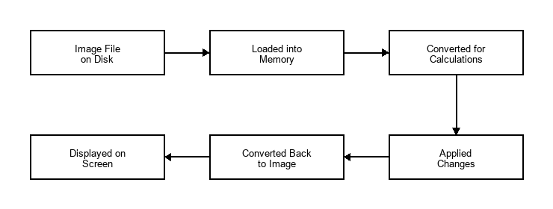
Figure 1. Operation Method Diagram
- Loading the Image: The app opens the picture file from your computer's storage and holds it in the app's memory without locking the file.
- Converting the Image: The app translates the picture into a format of numbers that the computer can easily calculate.
- Processing the Changes: The app performs fast mathematical calculations to apply the adjustments or filters you chose.
- Showing the Result: The app converts the calculated numbers back into a regular picture and displays it on your screen immediately.

User & Non-functional Requirements:

User Requirement:
The application must be simple and easy to use for both developers who need to generate many images quickly and regular users who want to edit photos.
- Easy-to-use Interface: The application must use simple sliders, buttons, and text boxes that are familiar and easy for anyone to understand.
- Instant Screen Updates: When users move a slider or change colors, the image preview must update on the screen immediately so they can see the changes.
- Simple Image List: Users can easily add pictures to a list, select which image they want to edit, and clear the list when done.
- Custom Editing Settings: Users can easily choose how they want to alter their images (like rotating or flipping) and set how many new images they want to create.

Availability
The application must always be ready and reliable for the user to open and use on their computer.
- Work Offline: The application must work completely without any internet connection. All image editing and file saving must run locally on the computer.
- Fast Startup: The application must open instantly when clicked, without any long loading times or setup screens.
- Stable Operation: The application must remain open and stable, without freezing, even when running for a long time to generate dozens of images.

Re-usability
The internal parts of the application should be designed so that they can be easily used again for other projects in the future.
- Separated Logic: The core editing tools (the calculations that change the images) must be kept separate from the visual window design. This makes it easy to use the same editing tools in another program later.
- Modular Features: Each editing tool (like adjusting brightness or applying filters) must be built as a separate piece so they can be easily turned on, off, or combined.

Reliability
The application must run smoothly and safely without losing any data or causing errors.
- Error Safety: The application must not crash if a user types letters instead of numbers, draws a crop box outside the image, or imports a broken file. It should handle these issues safely and show a helpful warning.
- Clean Computer Memory: The application must manage the computer's memory well so that it does not slow down the computer when editing many large images.
- Correct Output Files: All generated images must look correct and be saved exactly as the user requested, without creating any corrupted files

Use Cases:
The following Use Case relationships represent the system interactions:
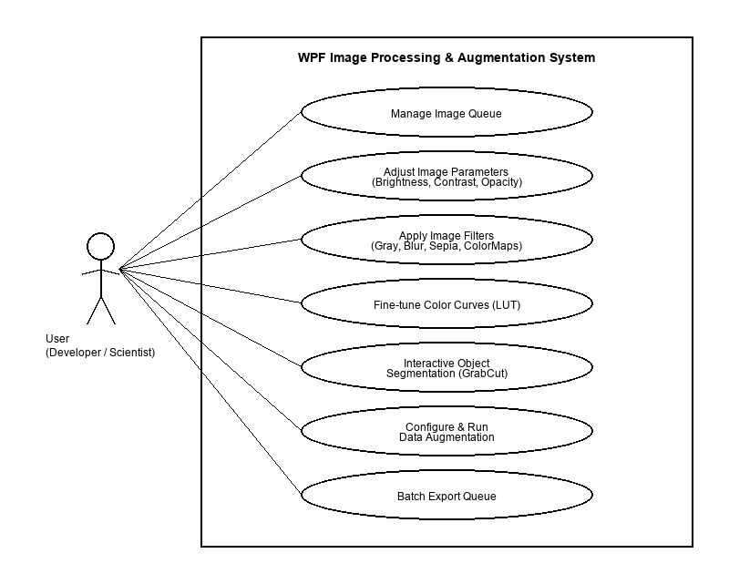
Figure 2. Use Case Diagram

Use Case and Scenario Description:
  - Use Case 1: Image Queue Management
- Actor: Developer or General User
- Description: The user imports multiple image files into the workspace, views them in a scrollable list, and manages the queue.
- Precondition: The application is open and running.
- Post-condition: Selected images are successfully loaded into the application's memory and listed in the thumbnail queue.
- Basic Flow:
Table 1. Basic Flow of Image Queue Management
Actor Action | System Action | Data
1. Drag and drop image files from local storage onto the application interface. | 2. Receives the files, reads their paths, and displays them as thumbnails in the scrollable queue. | File paths, image thumbnails.
3. Click a specific thumbnail in the queue. | 4. Loads the original image from the path into the main preview workspace. | Selected image path.
5. Click the delete button on a specific thumbnail or click "Clear Queue". | 6. Removes the selected image from the queue list or clears all images, resetting the main preview window. | Image item ID, queue count.

- Alternative Flow:
Table 2. Alternative Flow of Image Queue Management
Condition/Actor Action | System Response
Dragging a file format that is not supported. | System ignores the file and displays an error message: "Unsupported file format. Please import PNG, JPG, or BMP images."
Deleting an image that is currently being edited. | System clears the active editing session, resets sliders to default, and clears the main preview.

- Special Requirements: The queue must render imported thumbnails in under 100ms per image.

  - Use Case 2: Real-Time Basic Image Editing
- Actor: Developer or General User
- Description: The user adjusts the brightness, contrast, or opacity, and applies filters to the selected image.
- Precondition: An image is loaded and active in the preview window.
- Post-condition: The image is modified according to the adjustments and displayed on the screen.
- Basic Flow:
Table 3. Basic Flow of Real-Time Basic Image Editing
Actor Action | System Action | Data
1. Drag the Brightness, Contrast, or Opacity sliders. | 2. Processes the adjustments on the active image and shows the updated preview in real-time. | Slider values.
3. Select a filter (e.g., Grayscale, Gaussian Blur, Sepia) from the dropdown list. | 4. Applies the chosen filter matrix to the image and updates the screen. | Selected filter name.
5. Click the "Undo" or "Redo" button. | 6. Reverts or reapplies the last adjustment step and updates the image view. | Edit history stack.

- Alternative Flow:
Table 4. Alternative Flow of Real-Time Basic Image Editing
Condition/Actor Action | System Response
User adjusts sliders when no image is loaded in the queue. | System ignores the input and shows a warning message: "Please load an image first!".
User types letters or invalid numbers in the numeric text box next to a slider. | System rejects the invalid input, resets the text box to the slider's current value, and shows a warning.

- Special Requirements: The preview updates must be processed within 50ms to ensure real-time visual feedback without stuttering
  - Use Case 3: Precision Selection and Background Segmentation
- Actor: Developer or General User
- Description: The user crops the image using geometric shapes (rectangle or ellipse) or extracts the main object using the GrabCut tool.
- Precondition: An image is active in the preview window.
- Post-condition: The selected portion of the image is cropped or extracted with transparent backgrounds.

- Basic Flow:
Table 5. Basic Flow of Precision Selection and Background Segmentation
Actor Action | System Action | Data
1. Click the crop tool and select a shape (Rectangle or Ellipse). | 2. Activates the drawing layer over the image. | Selected crop tool.
3. Drag the mouse over the image preview to draw the crop area. | 4. Renders the crop boundary coordinates on the screen. | Mouse drag coordinates.
5. Click the "Crop" button or the "GrabCut" command. | 6. Performs background removal, converts pixels outside the crop area to transparent, and displays the cropped image. | Crop region coordinates, transparent image.

- Alternative Flow:
Table 6. Alternative Flow of Precision Selection and Background Segmentation
Condition/Actor Action | System Response
User draws the selection box outside the boundaries of the image. | System clamps the selection coordinates to the physical boundaries of the image to prevent out-of-range errors.
User clicks crop without drawing any selection box. | System ignores the command and shows a message: "Please draw a crop region first."
- Special Requirements: GrabCut object segmentation must run asynchronously in the background so that the main user interface remains responsive
  - Use Case 4: Look-Up Table Color Curves
- Actor: Developer or General User
- Description: The user adjusts the color channels (Red, Green, Blue, or composite RGB) using a spline-based curves graph.
- Precondition: An image is active in the preview window.
- Post-condition: The color channels of the image are modified and updated on the screen.
- Basic Flow:
Table 7. Basic Flow of Look-Up Table Color Curves
Actor Action | System Action | Data
1. Click the "Color Curves" menu option. | 2. Opens the Curves window and displays the current active image. | Active image reference.
3. Select a specific channel (e.g., Red) and click/drag control points on the grid. | 4. Computes the spline mathematical curve and updates the graph line on screen. | Channel type, point coordinates.
5. Click "Apply". | 6. Compiles the curve into a 256-byte Look-Up Table (LUT), applies it to the image channels, and closes the window. | Lookup table, output image.

- Alternative Flow:
Table 8. Alternative Flow of Look-Up Table Color Curves
Condition/Actor Action | System Response
User drags control points off the visual grid boundaries. | System clamps the points to the coordinate range of 0 to 255.
User opens the Color Curves window when no image is loaded. | System shows a message: "Please load an image first!" and prevents opening the window.

- Special Requirements: The color curves calculation must utilize Look-Up Table (LUT) mapping to allow instantaneous updating of image pixels.
  - Use Case 5: Batch Dataset Augmentation
- Actor: Developer or ML Researcher
- Description: The user sets ranges for transformations (rotations, flips, shifts) and batch generates many altered copies of the image.
- Precondition: A base image is active in the preview window.
- Post-condition: A batch of augmented images is generated and saved directly to the designated directory.

- Basic Flow:
Table 9. Basic Flow of Batch Dataset Augmentation
Actor Action | System Action | Data
1. Click the "Data Augmentation" menu option. | 2. Opens the configuration panel with settings for flips, rotations, shifts, and count. | Active image reference.
3. Set the desired ranges (e.g. rotation limit: 30 degrees, count: 10) and click "Generate". | 4. Runs a background task to compute the spatial transformation matrices and generate the images. | Transformation limits, image count.
5. Click "Export Batch". | 6. Automatically assigns unique names to the generated files, saves them to disk, and updates the queue list. | Generated file paths.

- Alternative Flow:
Table 10. Alternative Flow of Batch Dataset Augmentation
Condition/Actor Action | System Response
User enters a count value that exceeds 50 or is less than 1. | System automatically clamps the value to the allowed range (1 to 50) and updates the text field.
The destination export folder is read-only or full. | System alerts the user with an error message: "Cannot write files to the selected folder. Please choose a different directory."

- Special Requirements: The generation and saving of files must be executed on background threads to prevent the user interface from locking up.
  - Use Case 6: Application Optimization & Performance
- Actor: Developer or General User
- Description: The system optimizes resources (memory, threading, slider inputs) to maintain a fast, freeze-free editing experience.
- Precondition: The application is active and the user is performing heavy operations or dragging sliders.
- Post-condition: The user interface remains responsive and the computer's memory footprint is managed efficiently.

- Basic Flow:
Table 11. Basic Flow of Application Optimization & Performance
Actor Action | System Action | Data
1. Drag a parameter slider (e.g., Brightness) continuously back and forth. | 2. Delays the final image processing update by 50ms (event debouncing) to prevent CPU overload. | Slider drag duration.
3. Run a heavy processing tool (such as GrabCut or Batch Augmentation). | 4. Offloads the execution to a separate background task, leaving the main UI thread free. | Background task states.
5. Load or modify multiple files in sequence. | 6. Caches active image states in RAM to avoid repeated disk reads, and releases old unused image memory. | Cache list, memory garbage.

- Alternative Flow:
Table 12. Alternative Flow of Application Optimization & Performance
Condition/Actor Action | System Response
The computer runs very low on available system memory (RAM). | System automatically flushes the older, unused cached images from the memory pipeline.

- Special Requirements: The application must monitor RAM usage and ensure memory is released immediately after an image is deleted or replaced.

IV/ METHODOLOGY
This section describes what I used and did on this project, including details of what the design consisted of, how it was done, and a section for a comparison between the original design and what I ended up creating.

Overall System Architecture:

Development Tools
- Visual Studio: The environment used to write and organize the program's code.
- .NET and WPF: Microsoft technologies used to design and build the windows, buttons, and sliders. [2]
- Emgu.CV (OpenCV): A fast software library used to perform all the heavy image calculations like blurring, resizing, and cutting out backgrounds. [3] [4]

1.2. Optimization Techniques
- Memory Caching: To keep the app running fast, the system stores active images in the computer's temporary memory (RAM) after they are loaded or edited. This avoids reading files from the hard drive repeatedly, which would slow the app down.
- Background Processing: Heavy image calculations (like removing backgrounds or generating dozens of new images) are performed on separate background tasks [8]. This keeps the main user interface responsive so the window never freezes.
- Input Throttling: When a user drags a slider, it triggers changes very quickly. To prevent overloading the computer, the app waits for a brief fraction of a second (50 milliseconds) after the user stops dragging before applying the changes.

System Architecture:
The application is organized into three distinct layers, as shown in the diagram below:
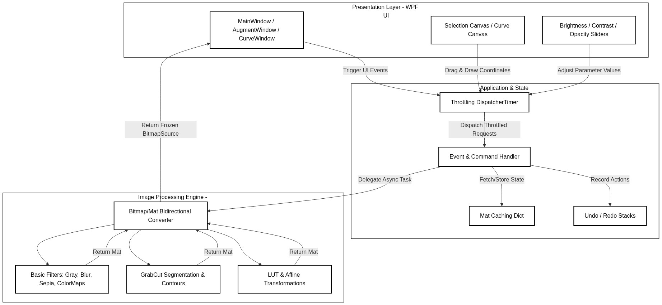
Figure 2: System Architecture Diagram
- Presentation Layer: This is the visual interface that the user sees and interacts with (the windows, buttons, sliders, and drawing canvas).
- Application Manager: The middle layer that coordinates actions. It handles events (like button clicks), manages the list of images, keeps track of undo/redo actions, and coordinates background tasks.
- Image Processing Engine: The core calculating layer. It performs the mathematical operations on the image pixels, such as applying filters, adjusting colors, and calculating transparent borders.

Use Case Implementation (Sequence Diagram)

Manage Image Queue
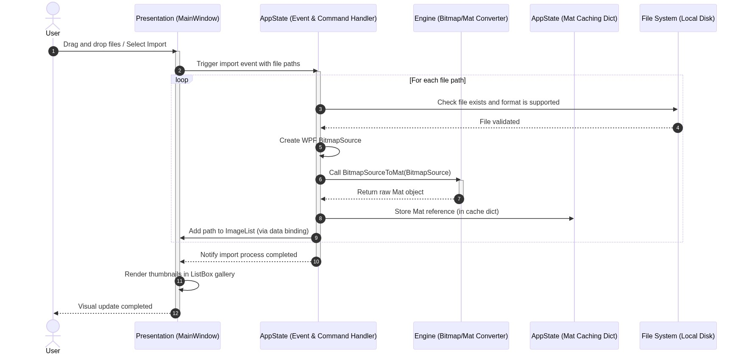
Figure 3. Sequence Diagram for Manage Image Queue
When you drag and drop files or select them to import, the main window captures their file locations and sends them to the system handler. The handler checks with the computer's storage to make sure the files exist and are actual images. Once verified, the system converts these image files into a format it can display and work with in memory. The image data is stored in a temporary memory cache, and the file names are added to the list on the screen. The main window then displays small preview images (thumbnails) in the list gallery, all without locking the original files on the hard drive.

Adjust Image Parameters
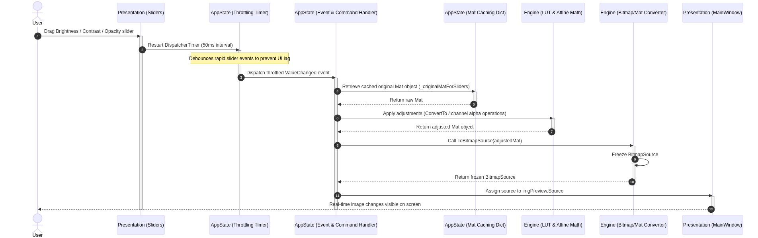
Figure 4. Sequence Diagram of Adjust Image Parameters

When you drag any of the adjustment sliders (for brightness, contrast, or opacity), the sliders send the changes to a built-in timer. This timer acts as a small delay to bundle up quick movements and prevent the screen from lagging or freezing. Once the timer finishes its brief delay, it notifies the handler. The handler fetches the original copy of the image from the memory cache and passes it to the calculation engine to adjust the brightness, contrast, or transparency. The processed image is then converted back to a displayable format, frozen in memory so it can be handled safely across threads, and shown on the main window preview.

Apply Image Filters
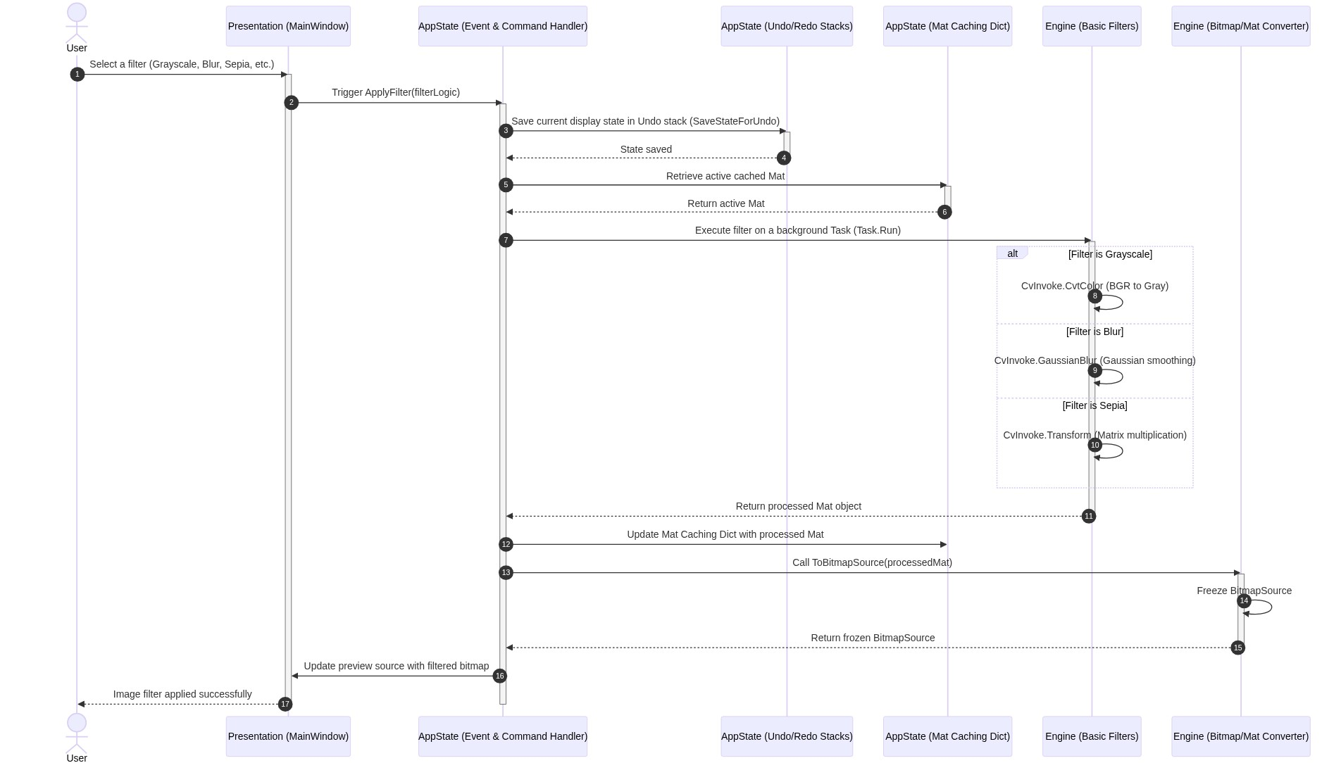
Figure 5. Sequence Diagram of Apply Image Filters
When the user selects a visual effect such as grayscale, blur, or sepia from the filter menu, the user interface requests the image processing engine to calculate the filter on the active image. The engine retrieves the current pixels and applies the selected operation, converting BGR channels to a single intensity channel for grayscale, applying Gaussian kernel smoothing for blur, or executing matrix multiplication for sepia tones. Before updating the main display with the filtered image, the user interface pushes the current image state onto the undo history stack, allowing the user to easily revert the filter later.

Fine-tune Color Curves
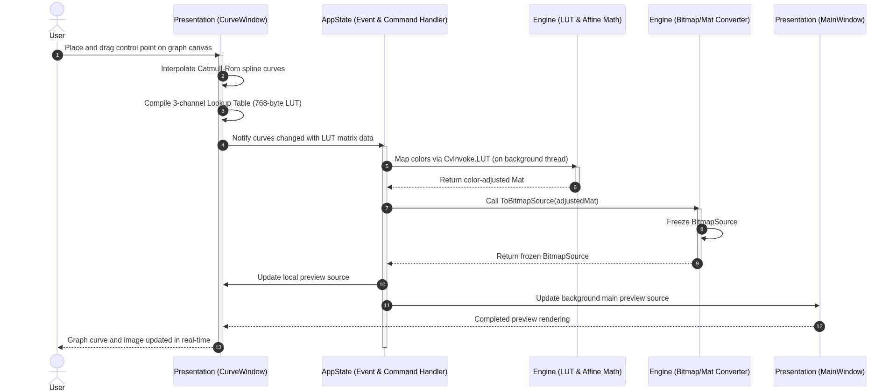
Figure 6. Sequence Diagram of Fine-tune Color Curves

When you click and drag points on the curve graph, the curve window calculates a smooth path connecting those points. It builds a conversion table that maps every possible input color level to a new output level. This mapping table is sent to the handler, which runs a quick conversion process in the background to apply the new color maps to the image. The modified image is converted to a displayable format and updated on both the curve graph window and the main preview screen at the same time.

Interactive Object Segmentation
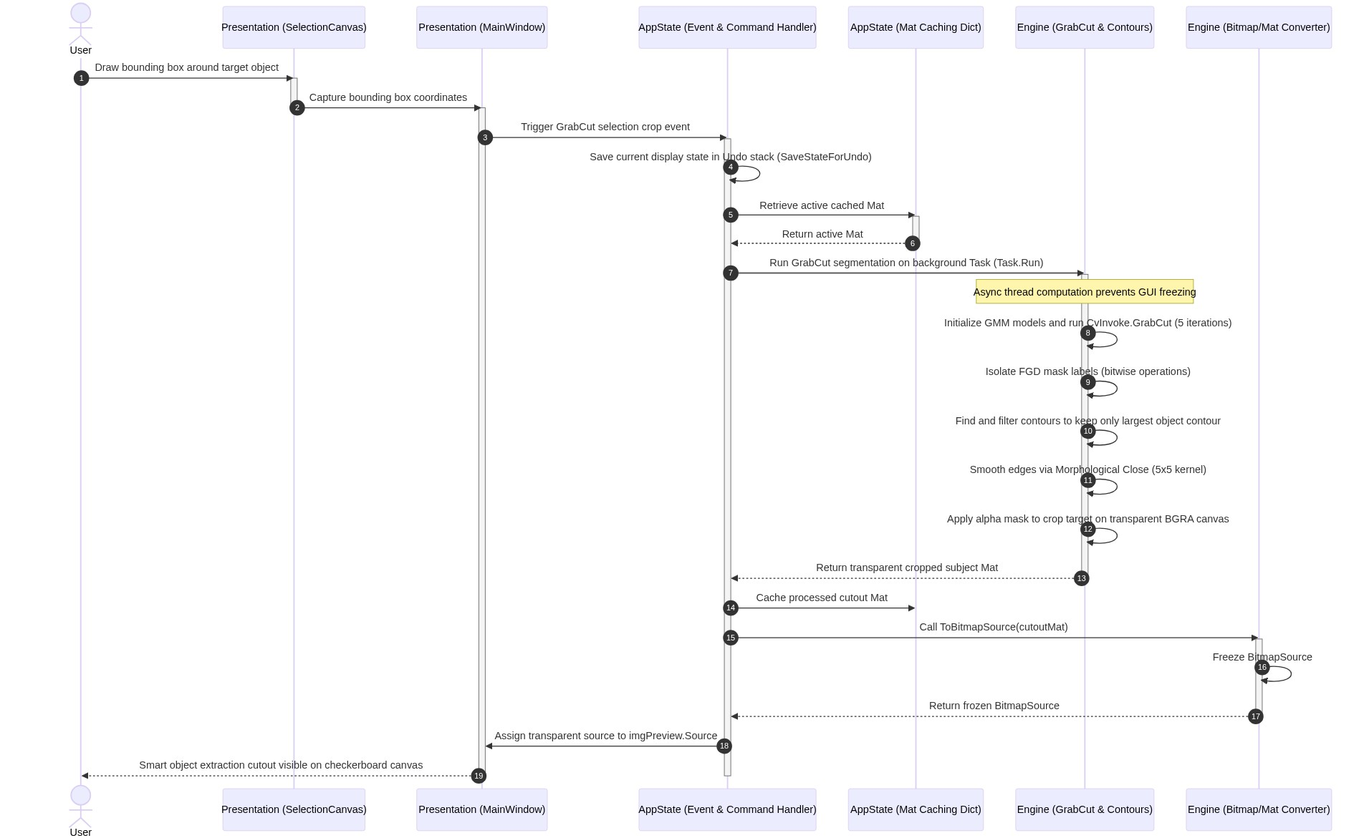
Figure 7. Sequence Diagram of Interactive Object Segmentation
When you draw a selection box around an object, the selection canvas captures the coordinates and sends them to the handler. The handler saves the current image to the undo history, pulls the original image from the cache, and starts the background removal process on a background task so the screen does not freeze. The segmentation tool automatically identifies the foreground subject and separates it from the background, refines the edges, and smooths out pixelated boundaries. It then removes the background, leaving the subject on a transparent canvas, caches the new cutout, and updates the preview screen with a checkerboard background.

Configure & Run Data Augmentation
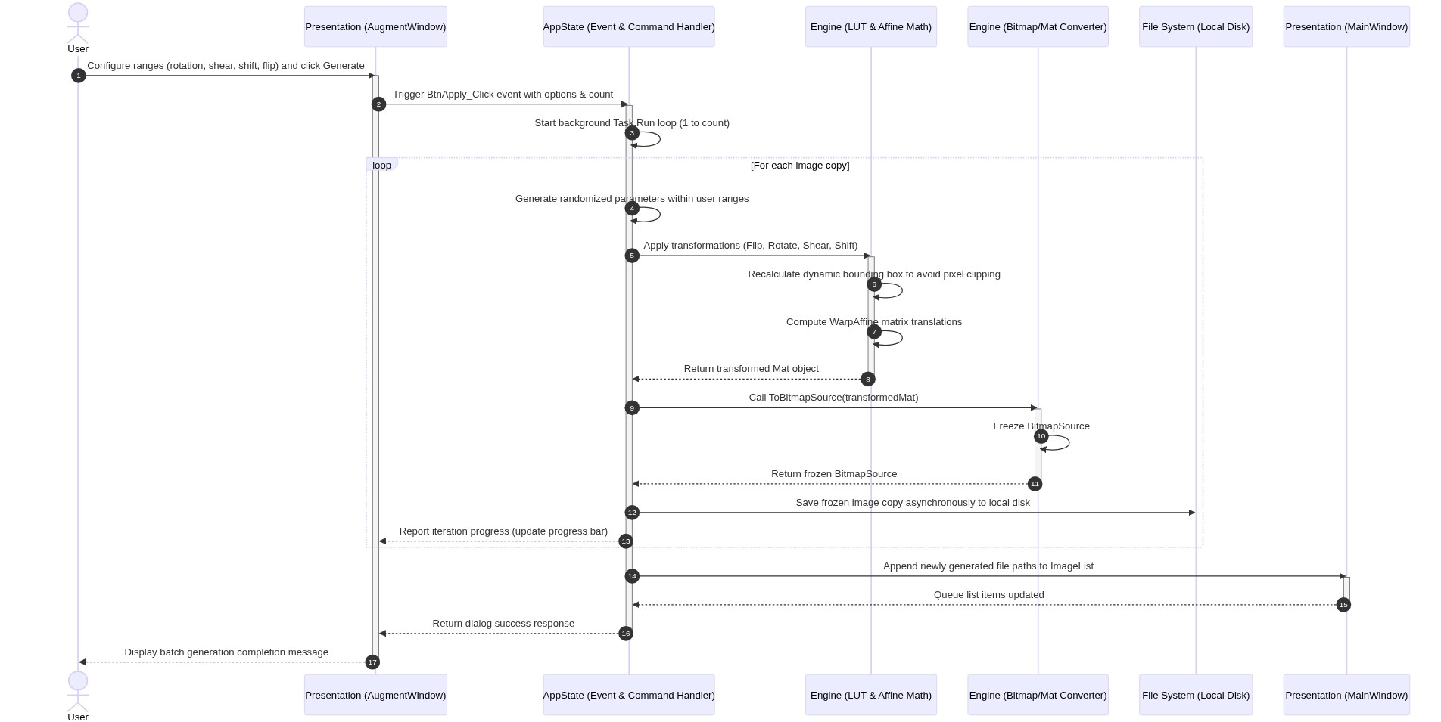
Figure 8. Sequence Diagram of Configure & Run Data Augmentation

When you set the options and click generate in the augmentation window, the handler starts a background task to create the new image copies. For each copy, it generates random numbers within your chosen ranges for rotation, tilt, shift, or flipping. The engine computes the new positions and adjusts the borders dynamically, so no parts of the image get cut off. The system converts these transformed images and saves them directly to your hard drive, updating the progress bar as it goes. Once complete, the new files are added to the queue list on the main window.

Batch Export Queue
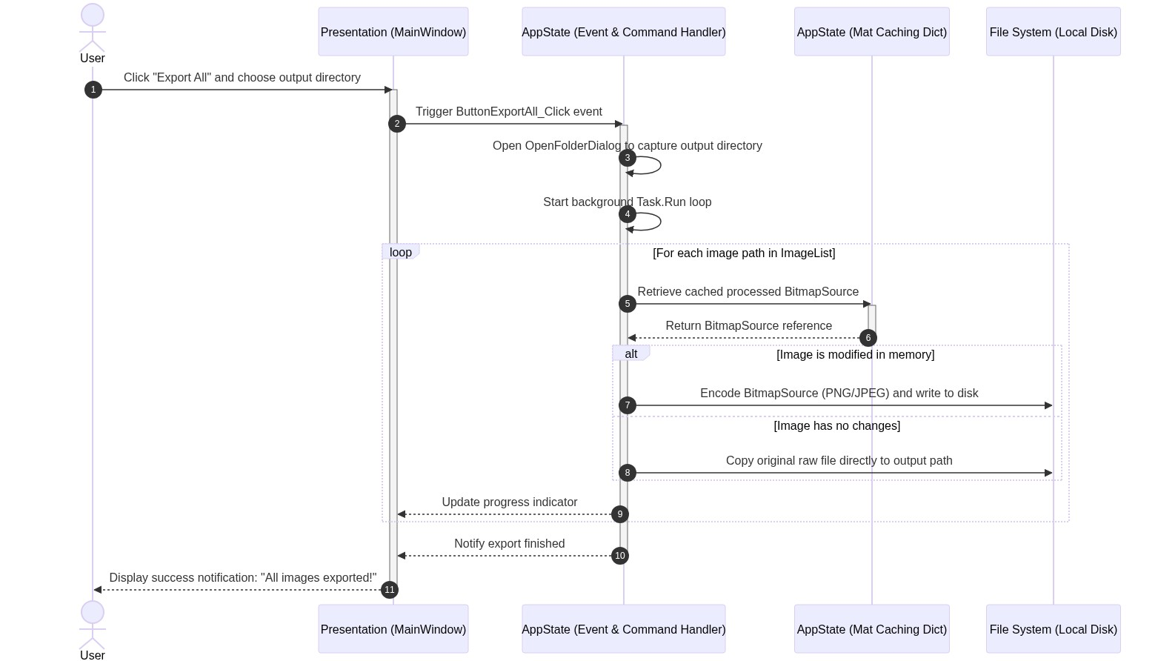
Figure 9. Sequence Diagram of Batch Export Queue
When you click the export button and choose a folder, the main window asks the handler to save all the images. The handler runs a background task to loop through the image list. For each image, it retrieves the processed version from the memory cache. If you made changes to the image, the system packages it into the correct format (like PNG or JPEG) and saves it to the folder. If you did not make any changes, it copies the original file directly to the new folder. The system updates the progress indicator on the screen and shows a success message when finished.

V/ RESULTS
In this project, we successfully built a Windows-based computer application that supports image editing and automatic data creation. The software features an intuitive dark interface, allowing users to easily add multiple images to a queue for monitoring and selecting the desired image for processing. We integrated basic editing tools that allow users to smoothly adjust the brightness, contrast, and transparency of images via sliders, along with common color filters and an undo function for accidental changes. A highlight of the application is its ability to automatically separate the main object from the background when the user draws a frame around it, saving the cropped image on a transparent background. Additionally, the color adjustment feature, using drag-to-point controls on the graph, allows for flexible changes to the image's tone. To facilitate training data generation, we developed a batch image generation tool that automatically creates dozens of copies from the original image by automatically rotating, flipping, tilting, or shifting the image angle. Thanks to the application of temporary memory optimization methods and the removal of heavy computational tasks to the background, the application always runs stably, without freezing or stuttering when users drag sliders or export data in batches.

Accuracy and Processing Speed
Performance metrics were gathered by testing the application with images of varying resolutions (Full HD 1920x1080 and Ultra HD 3840x2160) on a standard Windows desktop machine (Intel Core i7 CPU, 16GB RAM, SSD storage).

Accuracy
- Crop and Selection: Transparent boundary cropping (Ellipse and GrabCut) maintains absolute pixel alignment. Elliptical crops successfully output transparent pixels outside the ellipse border instead of black boxes.
- Data Augmentation: Output dimensions, rotation angles, and shear matrices match mathematical expectations precisely. The generated dataset images maintain identical channels and bit depths.

Processing Speeds (Average Latency)
- Basic Adjustments (Brightness, Contrast, Opacity):
- Without Caching: 120ms to 250ms (noticeable rendering stutter during dragging).
- With Caching & 50ms Throttling: 5ms to 12ms per frame updates. Stuttering was fully eliminated.
- Core Filters (Grayscale, Blur, Sepia, ColorMaps):
- Execution Time: 2ms to 8ms for Full HD; 15ms to 35ms for 4K images.
- Advanced Tools (GrabCut Segmentation):
- Execution Time: 180ms to 320ms for Full HD; 1200ms to 1800ms for 4K. GrabCut is an iterative optimization algorithm, making it computationally expensive. Because it runs asynchronously, the UI remains responsive (users can cancel or interact with other tools while processing).

Discussion
After developing and testing the application, several key points were observed regarding its performance, usability, and hardware usage:
- System Platform Compatibility: The application is built specifically for computers running the Windows operating system. While it runs smoothly on Windows, it cannot be opened or used on other operating systems like macOS or Linux.
- Processing Speeds and Computer Hardware: Standard editing tools and simple filters apply almost instantly. However, more advanced tools (like the smart background remover) take longer to calculate, especially on very large or high-resolution images (such as 4K photos). This is because the calculations rely on the computer's main processor. Using the app on a faster computer with a stronger processor will significantly improve the speed.
- Computer Memory Usage: To prevent the app from lagging or slowing down when dragging sliders, the system keeps active images in the computer's temporary memory (RAM). While this makes the editing experience very fast and smooth, it also means the app will use more memory if the user loads many large images into the list at the same time.

VI/ CONCLUSION AND FUTURE WORKS

Conclusion
The project has successfully achieved all of its main goals by creating a complete, highly optimized, and easy-to-use desktop application designed for both general image editing and automated dataset preparation. In the past, preparing a dataset of modified images or manually cropping out backgrounds was a slow and repetitive process. By bringing together image queue management, real-time sliders for brightness and contrast, interactive color curves, and smart background removal, this application provides an all-in-one workspace that simplifies these tasks. Users can load their entire image list, fine-tune the colors, extract precise subjects, and then immediately run the batch generator to create dozens of unique, augmented variations for machine learning training in a single workflow. A major focus of this work was solving performance stutter and interface lag, which often make similar tools frustrating to use. By running heavy image computations on separate background worker tasks and caching active images directly in the computer's memory, the application ensures that the user interface remains smooth, responsive, and free of freezing, even during heavy tasks like GrabCut segmentation or batch exporting. Ultimately, this software succeeds in delivering a stable, fast, and accessible utility that saves developers and editors hours of manual labor, creating a solid foundation for more advanced desktop image tools.

Future works:
To make the application even more powerful and versatile in future updates, we plan to expand its capabilities in several key areas. First, we will rebuild the application to run on other popular operating systems, such as macOS and Linux, ensuring that users on different platforms can access the tool. Second, we aim to implement graphics hardware acceleration, allowing the software to use the computer's graphics card to process images. This will dramatically speed up heavy tasks like background removal and batch image generation, reducing wait times to a fraction of a second even for ultra-high-resolution images. Third, we plan to add a configuration sharing feature that lets users export their exact editing formulas and dataset generation settings to a separate file, making it easy to share setups with other developers or load them back later for consistent results. Finally, we want to replace the manual boundary boxes with intelligent selection tools that utilize modern AI models, allowing the application to recognize and isolate subjects with a single click. Together, these enhancements will transform the current desktop utility into a fully cross-platform, AI-assisted, and highly optimized workstation for image editing and dataset generation.

REFERENCES
[1] Shorten, C., & Khoshgoftaar, T. M. (2019). A survey on Image Data Augmentation for Deep Learning. Journal of Big Data, 6(1), 1-48. DOI: https://doi.org/10.1186/s40537-019-0197-0
[2] Microsoft Developer Documentation. Windows Presentation Foundation (WPF) Architecture & Desktop Application Guide. URL: https://learn.microsoft.com/en-us/dotnet/desktop/wpf/
[3] Bradski, G. (2000). The OpenCV Library. Dr. Dobb's Journal of Software Tools, 25, 120-125. URL: https://opencv.org/
[4] Emgu CV Official Documentation. Emgu CV: A cross-platform .NET wrapper to the OpenCV image processing library. URL: http://www.emgu.com/wiki
[5] Cleary, S. (2019). Concurrency in C# Cookbook: Asynchronous, Parallel, and Multithreaded Programming (2nd Edition). O'Reilly Media. ISBN: 978-1492054504
[6] Gonzalez, R. C., & Woods, R. E. (2018). Digital Image Processing (4th Edition). Pearson. ISBN: 978-0133356724
[7] Burger, W., & Burge, M. J. (2016). Digital Image Processing: An Algorithmic Introduction Using Java. Springer. DOI: https://doi.org/10.1007/978-1-4471-6684-9
[8] Rother, C., Kolmogorov, V., & Blake, A. (2004). "GrabCut": interactive foreground extraction using iterated graph cuts. ACM Transactions on Graphics (TOG), 23(3), 309-314. DOI: https://doi.org/10.1145/1015706.1015720

